BOOKING MANAGEMENT SYSTEM

# END TERM REPORT

BY

**PAWAN KUMAR DUBEY-1221468, ROLL NO-41 MUHAMMED SHAD-12217962,ROLL NO-40 LOVE KUMAR -12221232, ROLL NO-42**

# SECTION – KOC39



School Of Computer Science Engineering Lovely Professional University,Jalandhar December-2022

# INTRODUCTIO

Our task is to design a website where people can book their movie tickets anytime from anywhere . It is very easy for the viewers to see the timing of the movies and the reviews of the movies .

# OBJECTIVE OF PROJECT

To make easy for the movie lover to book their show anytime and by seeing reviews Of the movie they will get to know more about movie cast and music.

# DESCRIPTION OF WORK DIVISION IN TERMS OF ROLES AMONG STUDENTS:-

Pawan kumar Dubey created the whole layout of the website, Home page , Objective And other section along with giving a finish touch.

Muhhmed shad made the final project report. Apart from that he had given some valuable Tips and advice to his group members.

Love kumar helps in designing the webpage.

1. 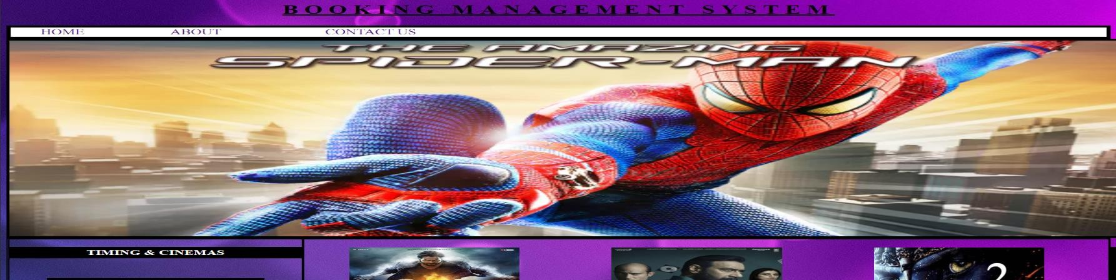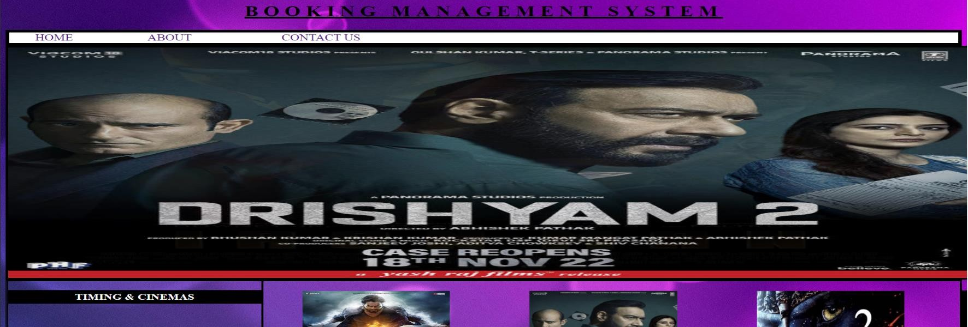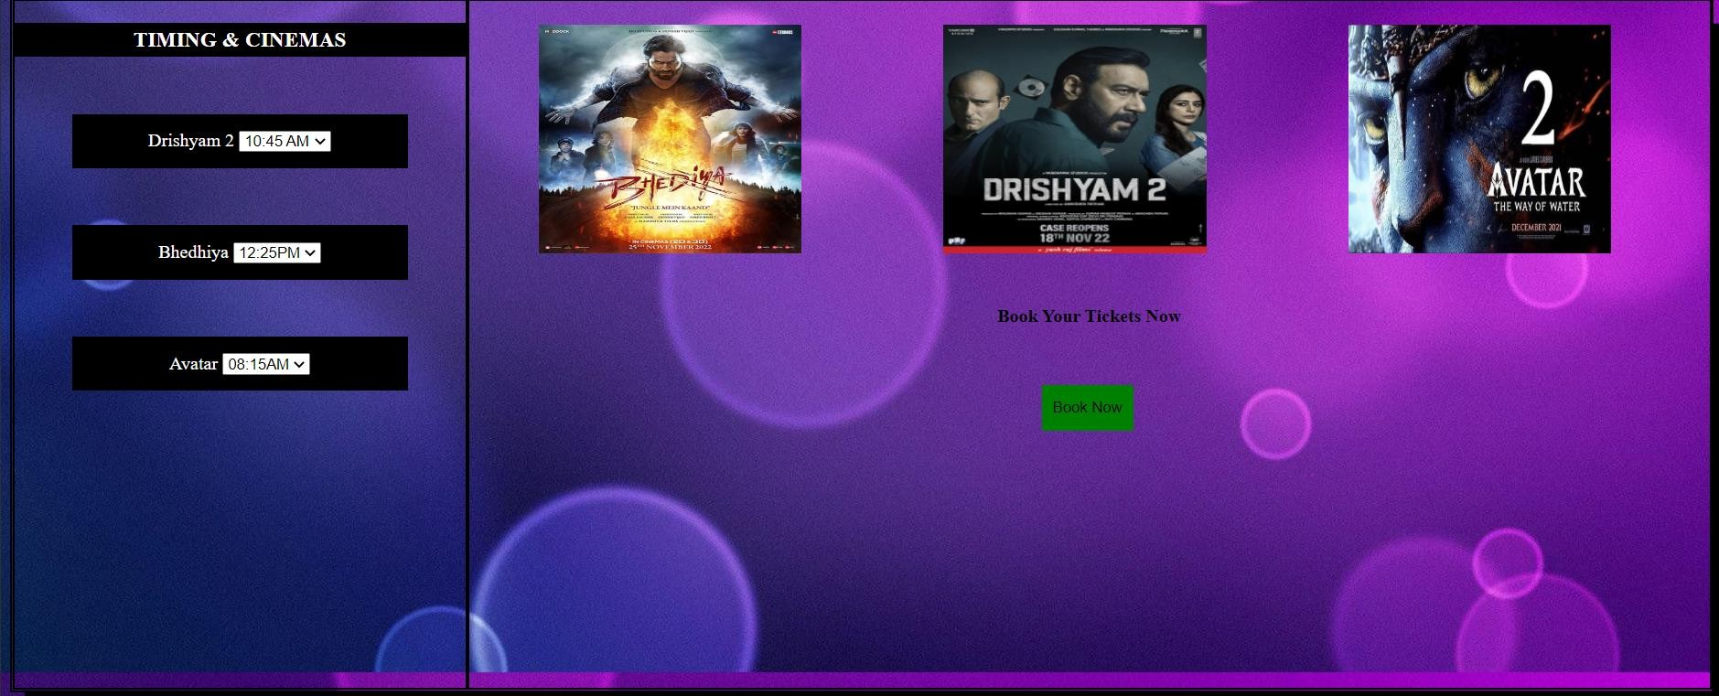SCREENSHOTS OF WEBSITE

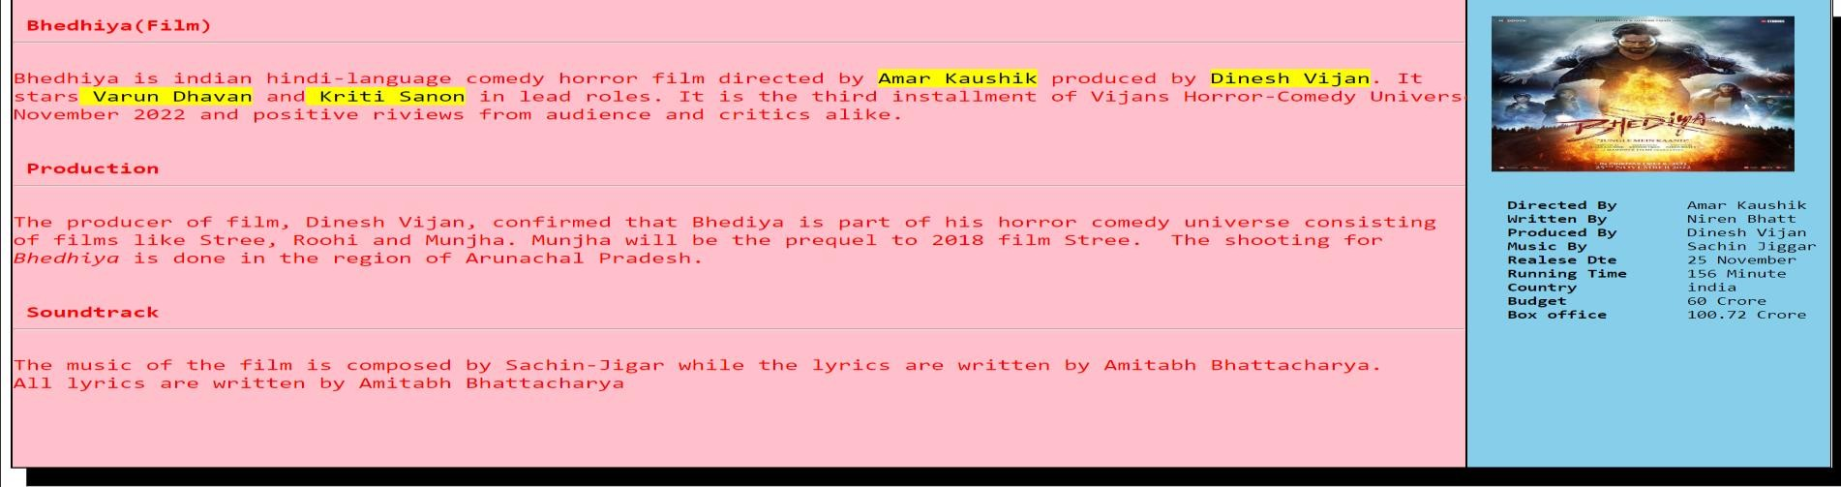

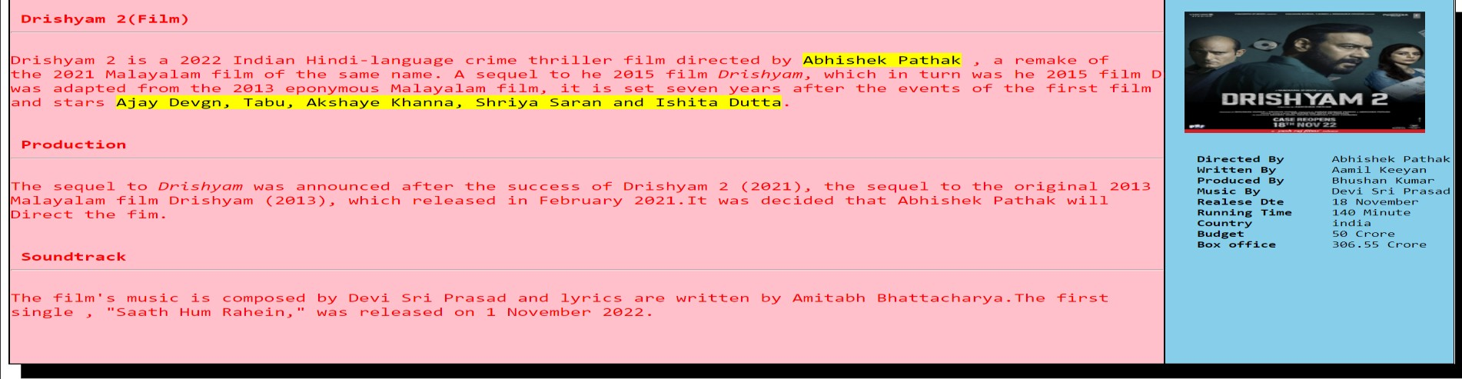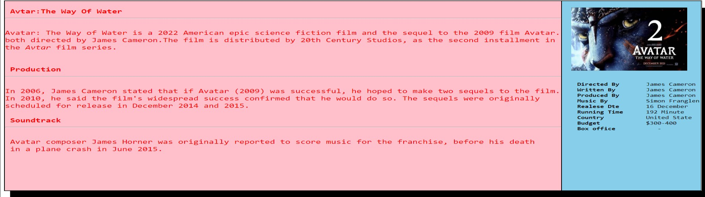

1. SCREENSHOTS OF CODE

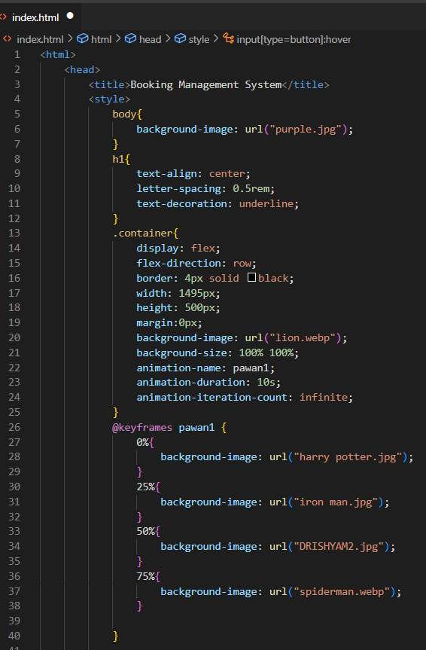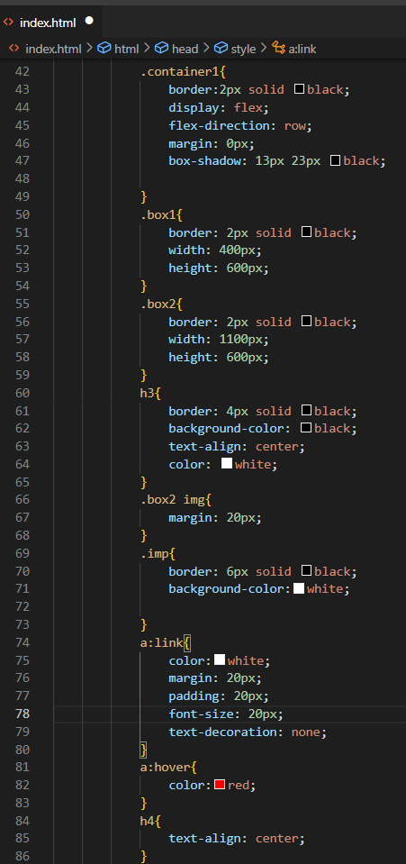

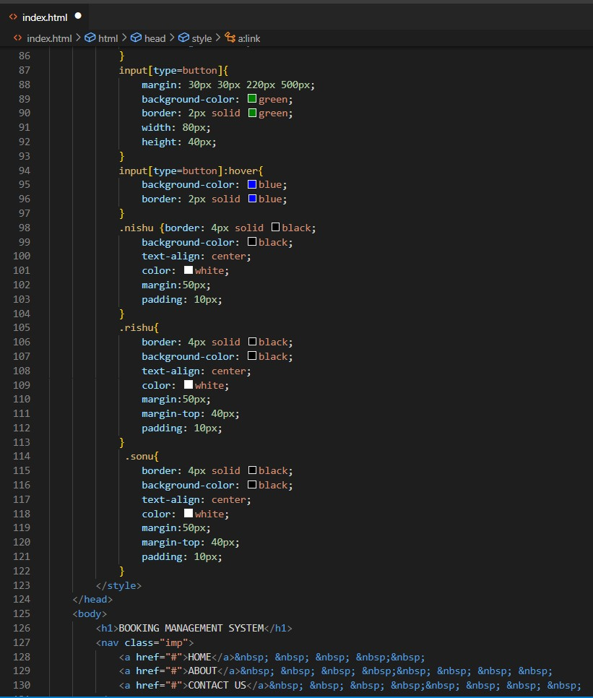 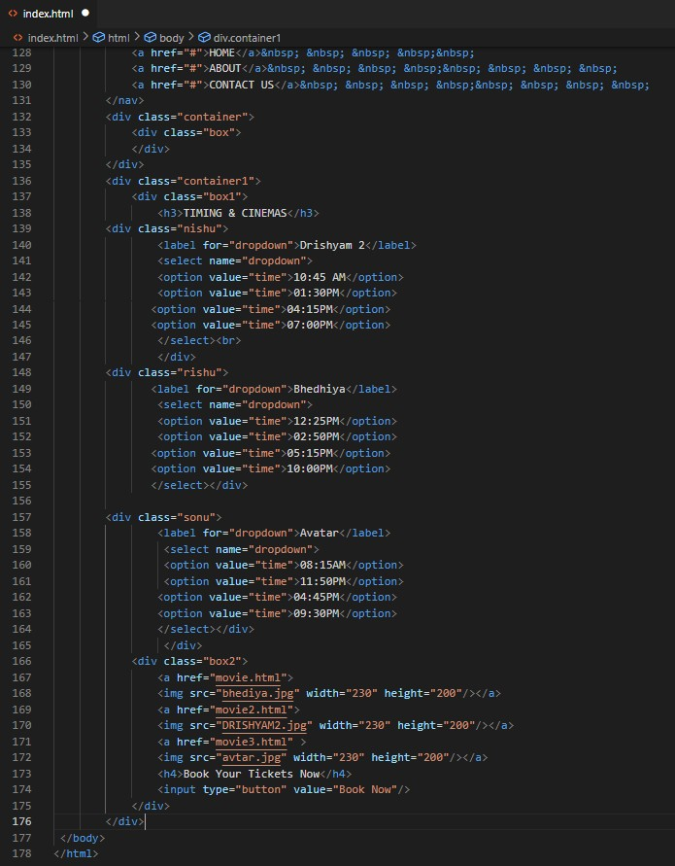

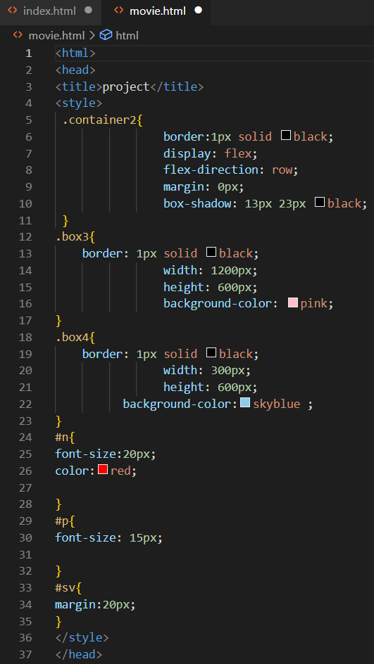 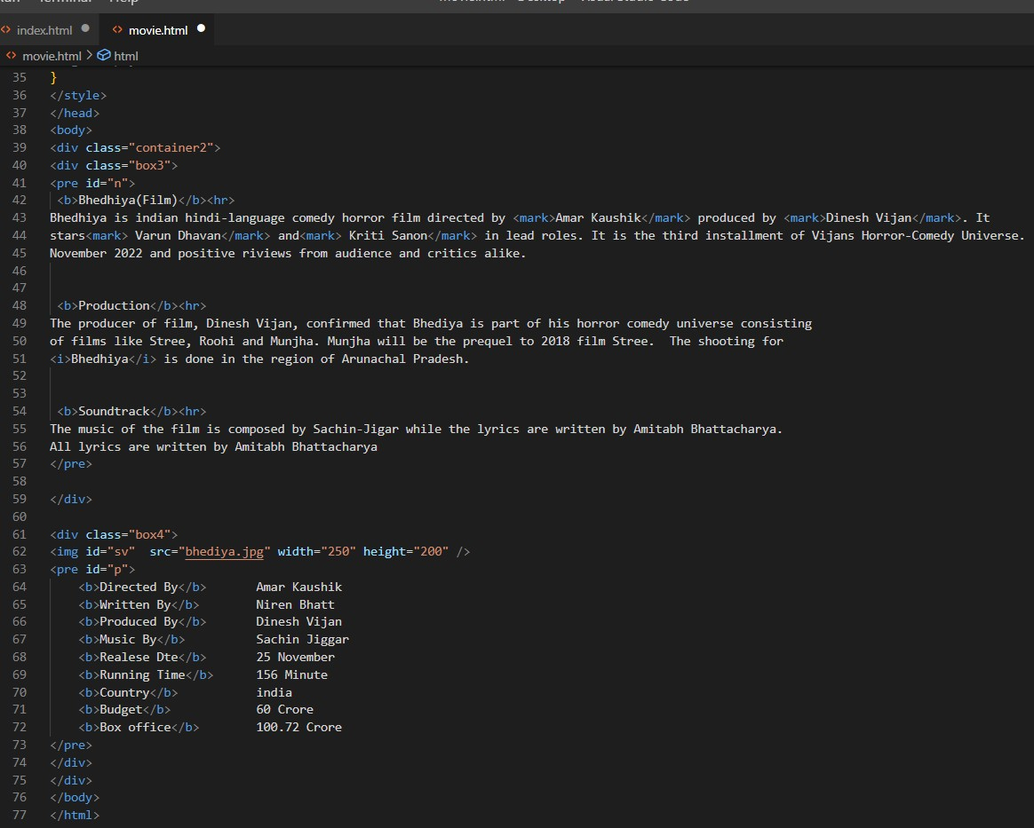

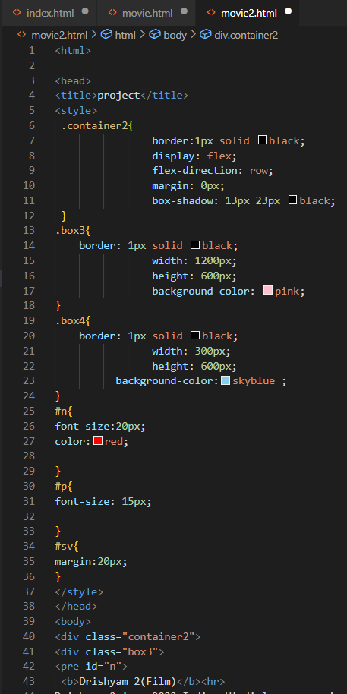 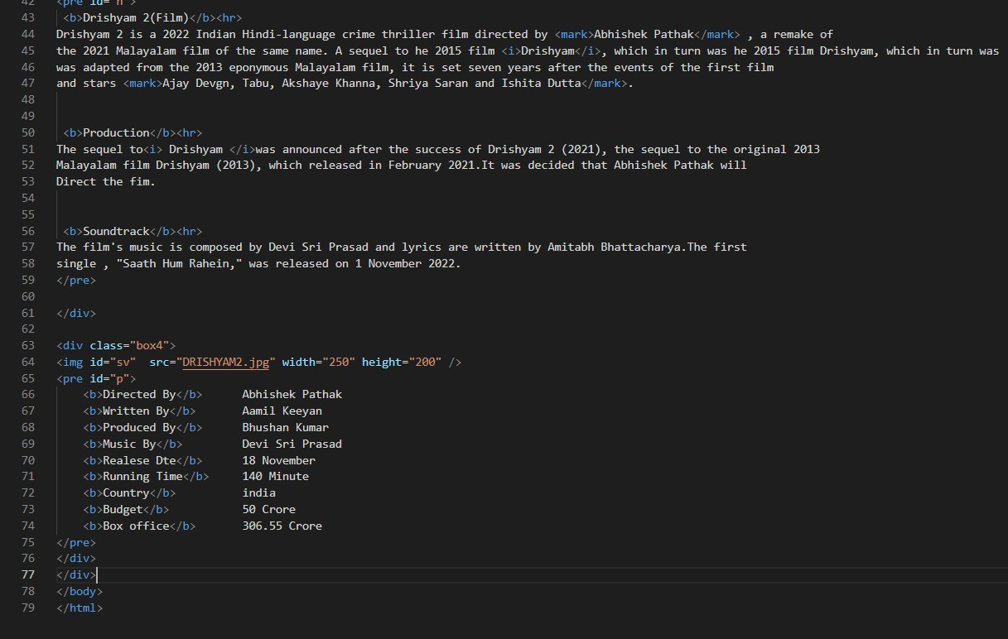

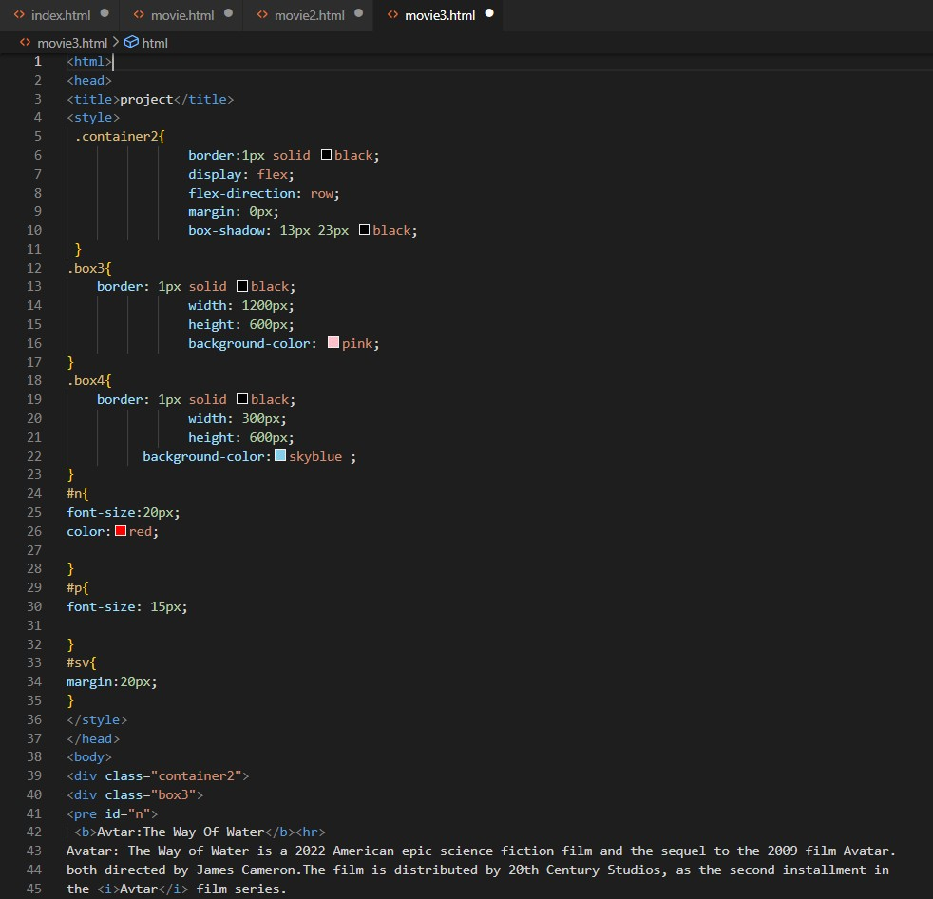 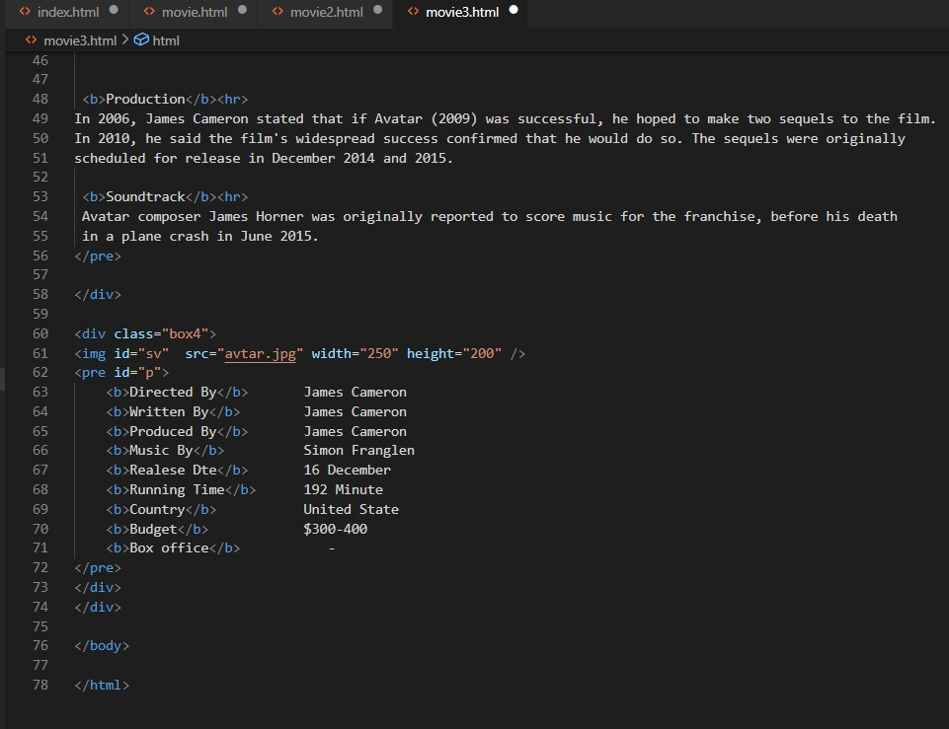

# FUTURE SCOPE OF THE PROJECT:-

* + We can promote our portfolio online.
  + We can effectively advertise on social media.
  + We can highlight customer feedback.
  + This system is developed keeping in view of current multiplex working pattern.
  + This is a web application for buying movie ticket online.
  + To increase the profit to obtain statistic information from the booking.